IMPORT DAYA USING TRASFORM MAPS
(SPREAD SHEET)
Project Planning Phase
Project Timeline
The project is planned to be completed in different stages, starting from understanding the project requirements and preparing the spreadsheet to developing, testing, documenting, and demonstrating the final project.
Phase| Activity
Phase 1| Brainstorming and Ideation
Phase 2| Requirement Analysis
Phase 3| Project Design
Phase 4| Project Planning
Phase 5| Project Development
Phase 6| Project Testing
Phase 7| Project Documentation
Phase 8| Project Demonstration
The timeline helps the team complete each stage systematically and within the planned schedule.
Task Allocation
The project activities are divided into different tasks to ensure that the work is completed efficiently.
The major tasks include:
Preparing the Excel spreadsheet.
Checking and organizing the input data.
Creating the Import Set in ServiceNow.
Uploading the spreadsheet data.
Creating the Transform Map.
Mapping source fields to target fields.
Running the transformation process.
Verifying the imported records.
Testing the project.
Preparing project documentation.
Preparing and recording the project demonstration.
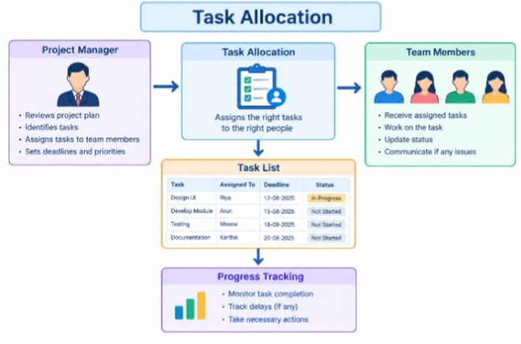
Team Member Responsibilities
Each team member is responsible for specific project activities. The responsibilities can be divided based on the team size and project requirements.
Role| Responsibility
Team Member 1| Prepare the Excel spreadsheet and input data
Team Member 2| Configure the Import Set and upload the spreadsheet
Team Member 3| Create the Transform Map and perform field mapping
Team Member 4| Perform testing and verify the imported records
Team Member 5| Prepare documentation and project demonstration

Team members should coordinate with each other and ensure that all project activities are completed properly.
Project Resources
The following resources are required for completing the project:
ServiceNow Instance
Excel Spreadsheet
Computer or Laptop
Internet Connection
Web Browser
Project Documentation
Screenshots of the implementation process
Project Reference Video
GitHub Repository for storing project files
These resources support the development, testing, documentation, and demonstration of the project.
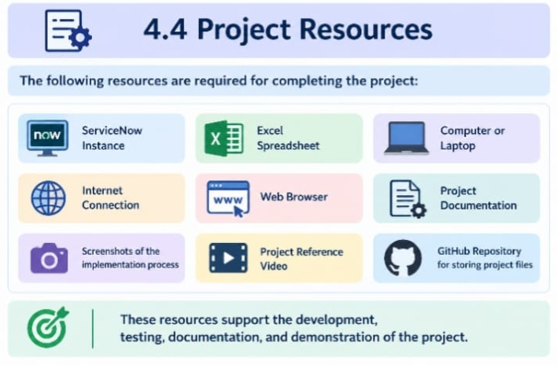
Project Milestones
The major milestones of the project are:
1. Finalizing the project idea.
2. Preparing the project requirements.
3. Designing the system workflow.
4. Preparing the Excel spreadsheet.
5. Importing the spreadsheet into ServiceNow.
6. Creating and configuring the Transform Map.
7. Mapping the source and target fields.
8. Running and verifying the transformation.
9. Completing project testing.
10. Preparing the project documentation.
11. Recording the project demonstration video.
12. Uploading the project files to the GitHub repository.
Risk Identification and Management
During the project development, certain risks may occur during data import and transformation. The major risks and their management methods are given below.
Risk| Management Method
Incorrect spreadsheet data| Check and validate the data before importing
Missing or incorrect field mapping| Verify source and target field mappings
Duplicate records| Check the data for duplicate entries before transformation
Import errors| Review Import Set and transformation results
Incorrect target data| Verify the records after transformation
Data format mismatch| Ensure that the spreadsheet data matches the target field format
Loss of data during import| Validate the source and target records after transformation

Proper planning, validation, and testing can help reduce these risks and ensure that the project is completed successfully.


